Gianpietro Gozzi IK2VTU

Some measurements taken on board 623 and 622 of the:
"Skanti switched mode power supply 48 Volt" Model 107 600 20
mounted in the HF transceiver Skanti TRP8400 D IT1, serial number 9291.
The measurements were made with a constant resistive load of 1 Amp and a constant output voltage of 48 Vcc.

Equipment used:
Multimeter FLUKE model 110 "true RMS multimeter"
Agilent Oscilloscope model DSO-X 2012

BOARD 623 (with negative reference potential -V connected to pin no. 5 of the PL2 connector)

D43 - D44 (BYW31)
A 32.29 Vcc
K 48.00 Vcc

Q17 - Q18 (BUV20)
B -3.5 Vcc
E 0 Vcc
C 32.28 Vcc

Q15 – Q21 (BUV27)
B -3.5 Vcc
E -3.985 Vcc
C 32.28 Vcc

Q16 – Q22 (TIP42A)
B - 4 Vcc
E - 3.5 Vcc
C - 5.25 Vcc

Q24 – Q14 (BC636)
B - 4.4 Vcc
E - 4 Vcc
C - 5.26 Vcc

BOARD 622, with negative reference potential -V connected to pin no. 5 of the PL2 connector.

Q13 – Q23 (BD140)
B 32 Vcc
E 32 Vcc
C - 3.9 Vcc

Measure with oscilloscope on PL4 pin1 - PL4 pin2
Amplitude: 12 Vpp - Frequency: 24,500 kHz

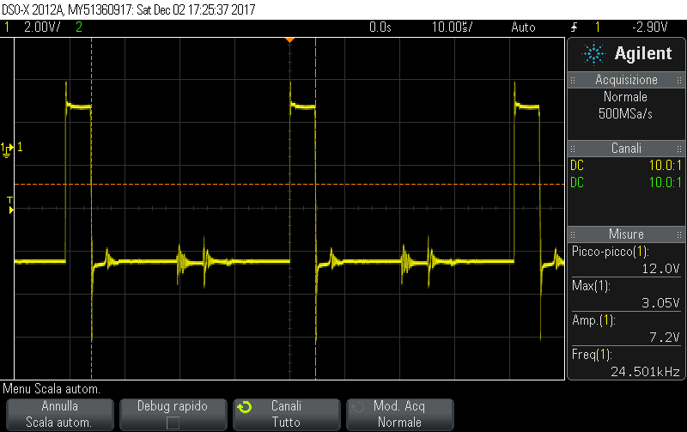

Q11 – Q19 (BC639)
B 0.5 Vcc
E 0.37 Vcc
C 32 V cc

Q12 – 20 (2N2907A)
B 0.5 Vcc
E 0.37 Vcc
C 0 Vcc

Q7 (TIP42C)
B 30.9 Vcc
E 31.5 Vcc
C 10.5 Vcc

Q8 (BD140)
B 31.13 Vcc
E 31.72 Vcc
C 8.96 Vcc

IC2 (UL N2883 or CA3183E)
Pin 1 0.854 Vcc
Pin 2 0.891 Vcc
Pin 3 0.837
Pin 4 0.168 Vcc
Pin 5 0 Vcc
Pin 6 0.708 Vcc
Pin 7 0.708 Vcc
Pin 8 0 Vcc
Pin 9 0 Vcc
Pin 10 0.708 Vcc
Pin 11 0 Vcc
Pin 12 0 Vcc
Pin 13 0 Vcc
Pin 14 8.68 Vcc
Pin 15 0.29 Vcc
Pin 16 0.969 Vcc

IC5 (HEF4047B or CD4047B)
Pin 1 4.892 Vcc
Pin 2 4.053 Vcc
Pin 3 4.038 Vcc
Pin 4 8.97 Vcc
Pin 5 8.97 Vcc
Pin 6 8.97 Vcc
Pin 7 0 Vcc
Pin 8 0 Vcc
Pin 9 0 Vcc
Pin 10 4.483 Vcc
Pin 11 4.484 Vcc
Pin 12 0 Vcc
Pin 13 4.91Vcc
Pin 14 8.97 Vcc

Measure with oscilloscope on pin1, pin2, pin 13 of IC5 (HEF4047B or CD4047B)
Amplitude 10.3 Vpp - Frequency 49.000 kHz

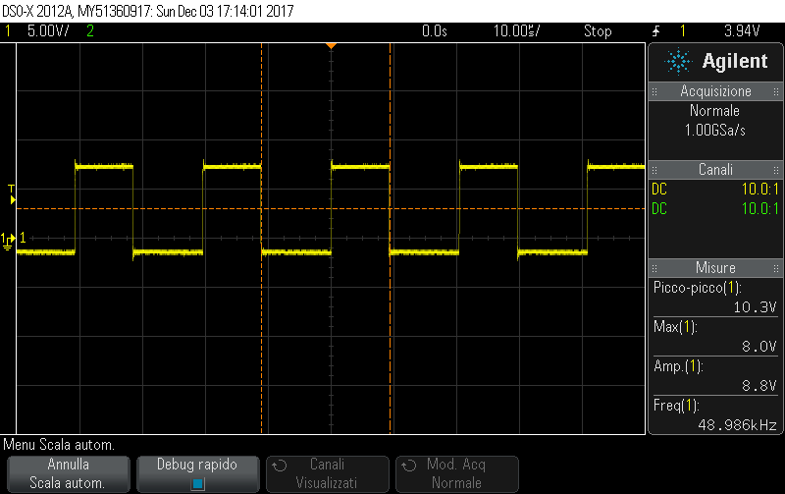

Measurement with oscilloscope on pin 3 of IC5 (HEF4047B or CD4047B)
Amplitude 17.9 Vpp - Frequency 48.267 kHz

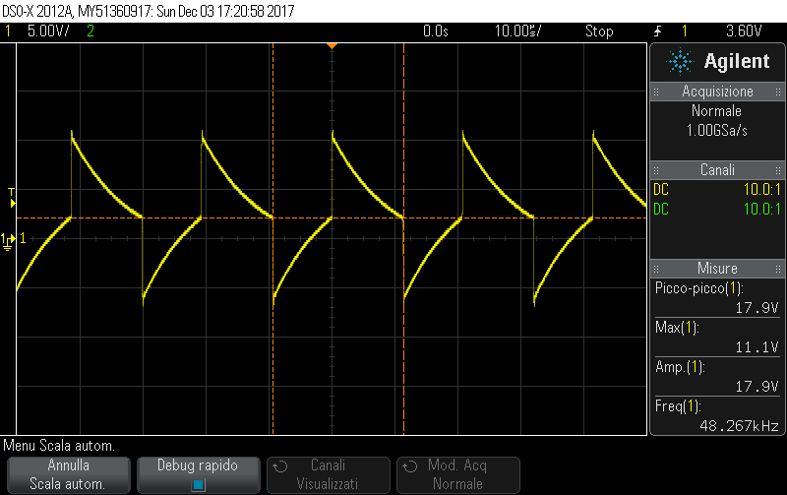

Measure with oscilloscope on pin10, pin 11 of IC5 (HEF4047B or CD4047B)
Amplitude 10.3 Vpp - Frequency 24.503 kHz

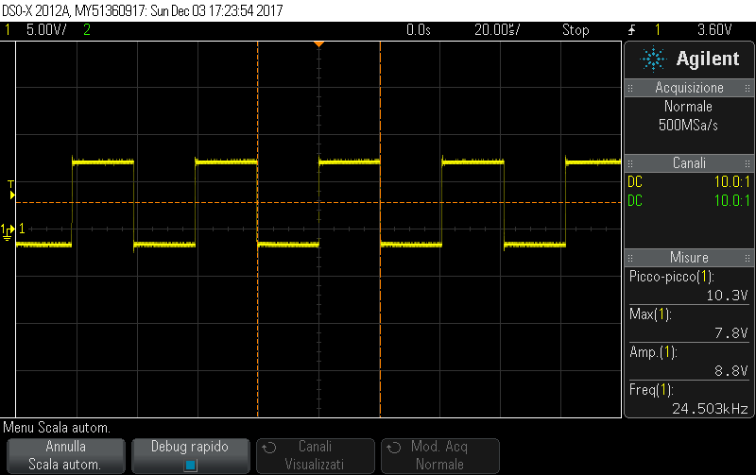

IC6 (LM2903N)
Pin 1 0.489 Vcc
Pin 2 4.474 Vcc
Pin 3 0.892 Vcc
Pin 4 0 Vcc
Pin 5 0.891 Vcc
Pin 6 4.474 Vcc
Pin 7 0.5 Vcc
Pin 8 8.96 Vcc

Measure with oscilloscope on pin1, pin7 of IC6 (LM2903N)
Amplitude 4.4 Vpp - Frequency 24.505 kHz

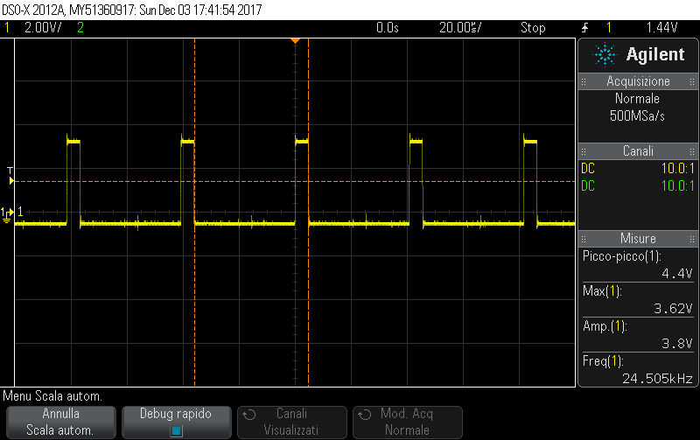

Measurement with oscilloscope on pin2, pin6 of IC6 (LM2903N)
Amplitude 8.2 Vpp - Frequency 24.476 kHz



